**Name: Debjyoti Sarkar Sumonta**

**Student ID: 22341019**

**CSE370 Section 2**

CREATE TABLE Employee (

employee_id CHAR(10),

first_name VARCHAR(20),

last_name VARCHAR(20),

email VARCHAR(60),

phone_number CHAR(14),

hire_date DATE,

job_id CHAR(10),

salary INT,

commission_pct DECIMAL(5,3),

manager_id CHAR(10),

department_id CHAR(10),

PRIMARY KEY (employee_id, job_id, manager_id, department_id)

);

INSERT INTO Employee(employee_id,first_name,last_name,email,phone_number,hire_date,job_id,salary,commission_pct,manager_id,department_id) VALUES

('EMP001', 'John', 'Doe', 'john.doe@email.com', '+1234567890', '2022-01-15', 'JOB001', 50000, 0.05, 'MNG001', 'DPT001'),

('EMP002', 'Jane', 'Smith', 'jane.smith@email.com', '+9876543210', '2022-02-20', 'JOB002', 60000, 0.08, 'MNG002', 'DPT002'),

('EMP003', 'Robert', 'Johnson', 'robert.johnson@email.com', '+3456789012', '2022-03-10', 'JOB003', 55000, 0.03, 'MNG001', 'DPT003'),

('EMP004', 'Maria', 'Rodriguez', 'maria.rodriguez@email.com', '+6543210987', '2022-04-05', 'JOB002', 62000, 0.07, 'MNG003', 'DPT001'),

('EMP005', 'Michael', 'Brown', 'michael.brown@email.com', '+2345678901', '2022-05-12', 'JOB001', 53000, 0.02, 'MNG002', 'DPT004'),

('EMP006', 'Emily', 'Davis', 'emily.davis@email.com', '+8765432109', '2022-06-18', 'JOB004', 58000, 0.06, 'MNG003', 'DPT002'),

('EMP007', 'Christopher', 'Lee', 'christopher.lee@email.com', '+4567890123', '2022-07-25', 'JOB003', 59000, 0.04, 'MNG001', 'DPT005'),

('EMP008', 'Olivia', 'White', 'olivia.white@email.com', '+7890123456', '2022-08-30', 'JOB002', 61000, 0.09, 'MNG002', 'DPT006'),

('EMP009', 'Daniel', 'Kim', 'daniel.kim@email.com', '+3210987654', '2022-09-05', 'JOB001', 54000, 0.01, 'MNG003', 'DPT007'),

('EMP010', 'Sophia', 'Wang', 'sophia.wang@email.com', '+5432109876', '2022-10-10', 'JOB004', 57000, 0.05, 'MNG001', 'DPT004');

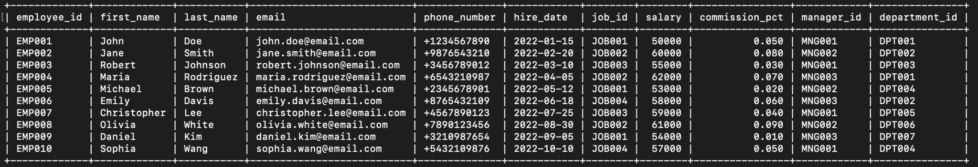

**TASK 1:**

SELECT first_name, last_name, email, phone_number, hire_date, department_id

FROM Employee WHERE hire_date = (SELECT MAX(hire_date) FROM Employee);

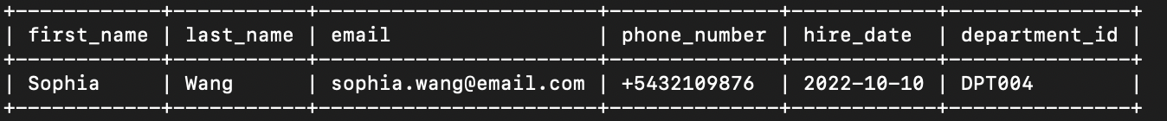

**TASK 2:**

SELECT first_name, last_name, employee_id, phone_number, salary, department_id

FROM Employee WHERE (department_id, salary) IN

(SELECT department_id, MIN(salary) FROM Employee GROUP BY department_id);

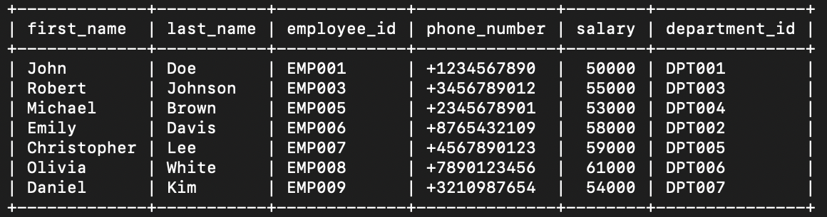

**TASK 3:**

SELECT first_name, last_name, employee_id, commission_pct, department_id

FROM Employee

WHERE department_id = 'DPT007'

AND commission_pct < (SELECT MIN(commission_pct) FROM Employee WHERE department_id = 'DPT005');

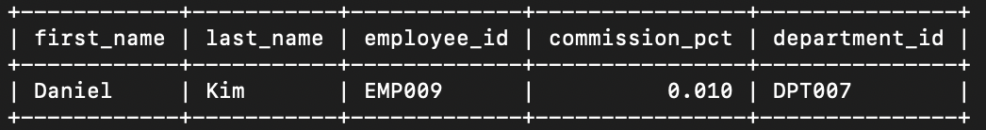

**TASK 4:**

SELECT department_id, COUNT(*) as total_employee

FROM Employee

WHERE department_id NOT IN

(SELECT department_id FROM Employee WHERE salary < 30000)

GROUP BY department_id;

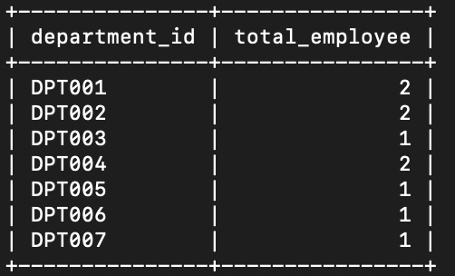

**TASK 5:**

SELECT department_id, job_id, commission_pct

FROM Employee e1 WHERE job_id NOT IN

(SELECT job_id FROM Employee e2

WHERE commission_pct >

(SELECT MIN(commission_pct) FROM Employee e3 WHERE e3.department_id = e2.department_id))

GROUP BY department_id, job_id, commission_pct;

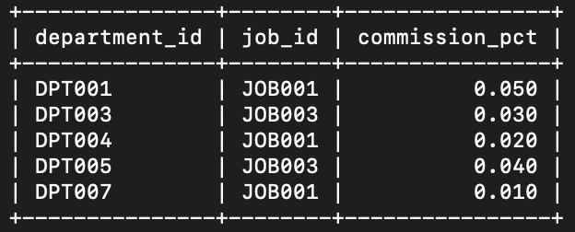

**TASK 6:**

SELECT manager_id FROM Employee WHERE manager_id not in (

SELECT manager_id FROM Employee WHERE salary < 3500

);

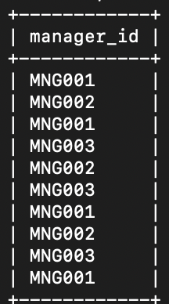

**TASK 7:**

SELECT first_name, last_name, employee_id, email, salary, department_id, commission_pct

FROM Employee WHERE (manager_id, commission_pct) IN

(SELECT manager_id, MIN(commission_pct) FROM Employee GROUP BY manager_id);

